**“Experiment 2: Measurement of *g*”**

Christina Oliveira; UID: 204-803-448

October 17, 2017

Tuesday 9AM

TA: Paokuan Chin

Lab Partner: Rosanna Rico

Christina Oliveira

**Experiment 2: Measurement of *g***

**Worksheet:**

**2. Derivation**

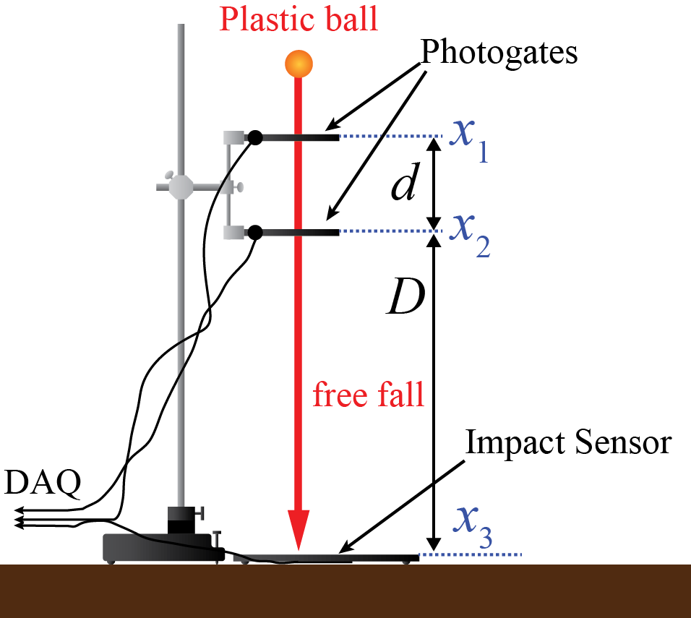

Figure 1: Set up for Ball-Drop Method. Figure reproduced (with permission) from Figure 2.1 by Campbell W.C. et al.1 Here, the setup of the ball-drop method is shown in order to clarify the meaning of the variables used in the derivation of Equation 2.1. As shown, d is the distance between the two photogates, and D is the distance between the second photogate and the impact sensor.

Equation 2.1 in the Lab Manual is:

$$g= \left(\frac{2}{T_{1}+T_{2}}\right)\left(\frac{D}{T_{2}}-\frac{d}{T_{1}}\right)$$

Where, from Figure 1:

d = Vertical distance in meters between the two photogates (a constant)

D = Vertical distance in meters between the second photogate and the impact sensor

T1 = Time in seconds for the ball to travel distance d

T2 = Time in seconds for the ball to travel distance D

g = The resulting gravitational acceleration

Since we are assuming constant acceleration equation 2.1 can be derived using the first kinematic equation:

$$Δy=v_{0}t+\frac{1}{2}at^{2}$$

Plug in equivalent values for the first part of the motion (between the photogates):

$$d=v_{0}T_{1}+\frac{1}{2}g{T_{1}}^{2}$$

Solve for $v_{0}$:

$$v_{0}=\frac{d}{T_{1}}-\frac{1}{2}gT_{1}$$

Plug in equivalent values for the entire motion (between the first photogate and the impact sensor) into the first kinematic equation again:

$$Δy=v_{0}t+\frac{1}{2}at^{2}$$

$$D+d=v_{0}{(T}_{1}+T_{2})+\frac{1}{2}g{{(T}_{1}+T_{2})}^{2}$$

Solve for D and simplify:

$$D= v_{0}T_{2}+gT_{1}T_{2}+\frac{1}{2}g{T_{2}}^{2}$$

Substitute $v_{0}$ for the equation found from the first part of the motion:

$$D=(\frac{d}{T_{1}}-\frac{1}{2}gT_{1})T_{2}+gT_{1}T_{2}+\frac{1}{2}g{T_{2}}^{2}$$

Simplify:

$$g= \left(\frac{2}{T_{1}+T_{2}}\right)\left(\frac{D}{T_{2}}-\frac{d}{T_{1}}\right)$$

**3. Plots**

Figure 2: Experimental Acceleration due to Gravity using the Ball-Drop Method. The vertical lines of data points represent the experimental values for the ball’s acceleration. Each vertical line represents a different distance, D, which is the distance between the second photogate and the impact sensor. For each D, the average acceleration calculated for that trial is marked with a green and red marker. The red dotted fit line then shows the best liner representation of the measured acceleration by finding the linear relationship between the average values. The fit line is of the form y=ax+b where a= 0.0692 and b=9.6238.

Figure 3. Experimental Acceleration due to Gravity using the Comb Method. The four sets of data represent four of the trials using the comb method. There are 35 data points on each, representing the 35 wavelengths of the comb. Each trial has a polynomial fit line of degree two of the form y= ax2+bx+c. The equation for each trial’s data is noted in the corresponding color on the graph. The experimental value of g using this method is extrapolated from the equation of each fit line as 2 multiplied by each value for a. The uncertainties of these values were calculated using quadratic regression in Excel, and the results of these calculations are shown in Table 1.

**4. Data Tables**

|  |  |  |  |
| --- | --- | --- | --- |
| Trial | Photogate Spacing  d (m) | Gap to Impact Sensor  D (m) | Measured Acceleration  *g* (m/s2) |
| 1 | 0.083 | 0.188 | 9.599 ± .006 |
| 2 | 0.083 | 0.385 | 9.692 ± .005 |
| 3 | 0.083 | 0.604 | 9.694 ± .005 |
| 4 | 0.083 | 0.784 | 9.651 ± .003 |
| 5 | 0.083 | 0.898 | 9.680 ± .004 |

Table 1. Data and Experimental Acceleration for the Ball Drop Method. The systematic uncertainty of d and D (columns 2 and 3) was found to be ±.001m. The distance between the first and second photogate, d, remained constant at 0.083 ± .001m while the distance between the second photogate and the impact sensor was varied. The measured acceleration, g, was then found using Equation 2.1 derived earlier, and the uncertainties propagated appropriately.

|  |  |  |  |
| --- | --- | --- | --- |
| Trial | Distance between slots  λ (m) | Comb Slots | Measured Acceleration  *g* (m/s2) |
| 1 | 0.008 | 35 | 10.60 ± .08 |
| 2 | 0.008 | 35 | 10.87 ± .06 |
| 3 | 0.008 | 35 | 10.96 ± .03 |
| 4 | 0.008 | 35 | 11.12 ± .05 |
| 5 | 0.008 | 35 | 11.21 ± .03 |

Table 2. Acceleration Derivation for the Comb Method. The systematic uncertainty of λ (column 2) was found to be ±.001m. Since the same comb was used for each trial, the distance between the slots on the comb, λ, remained constant at 0.083 ± .001m, as well as the number of slots, 35. The experimental acceleration was found by doubling the first coefficients of the quadratic fit line of each trial.

**5. Conclusion**

|  |  |
| --- | --- |
| Trial | Percent Error |
| 1 | 2.01% |
| 2 | 1.05% |
| 3 | 1.04% |
| 4 | 1.47% |
| 5 | 1.18% |

Table 3. Percent Errors for the Ball Drop Method. To calculate these errors, the data for the experimental accelerations from Table 1 and the expected g in Knudsen Hall at UCLA, where the experiment was conducted, (9.7955 ±.0003 m/s2)1 were used.

|  |  |
| --- | --- |
| Trial | Percent Error |
| 1 | 8.21% |
| 2 | 10.96% |
| 3 | 11.89% |
| 4 | 13.52% |
| 5 | 14.44% |

Table 4. Percent Errors for the Comb Method. To calculate these errors, the data for the experimental accelerations from Table 2 and the expected g in Knudsen Hall at UCLA, where the experiment was conducted, (9.7955 ±.0003 m/s2)1 were used.

From the percent errors calculated in Table 3 and Table 4, Trial 3 of the ball drop method had the closest acceleration to the expected one, with a percent error of 1.04%. From this lowest value, the other percent errors for the ball drop method didn’t vary much, ranging up to 2.01% for trial 1. This means that the results from the ball from method were both precise and fairly accurate. All of the values were slightly below the expected value by a similar degree, which suggests a systematic error, albeit slight. However, for the comb method, the results were neither precise nor accurate. The lowest percent error for this method was 8.21%, a fairly significant error. The errors for this method also varied much more than the ball drop method, going all the way up to 14.44%. From this, it was gathered that the ball drop method was the better method since it had both the better accuracy and precision. This is likely due to the wide range of sources of errors that were introduced with the comb method. One source of error noticed during the experiment was the combs deviation from a straight vertical path. This would have either shortened or lengthened the actual wavelength or number of slots recorded by the equipment, therefore increasing or decreasing the measured value for g. Another source of error was the fact that air resistance was not taken into account with either experiment. Air resistance slows down a falling body, and, if accounted for, would decrease the expected *g*. To improve the experiment, a sort of funnel or other mechanism could have been used for the comb method in order to avoid this non-vertical displacement.

**6. Extra Credit**

Throughout the comb method experiment, the biggest issue with the comb was getting it to fall vertically straight through the photogate. For our tests, we tried a couple different methods to try to eliminate this source of error, here only the best two are mentioned. For the first, tape was added to the far side of the photogate to prevent it slipping out toward the back. Then, a hardcover notebook was added in addition to the tape on the opposite side to create a sort of tunnel for the comb to pass through. The data gathered as a result is as follows:

Figure 4. Experimental Acceleration Using the Tape Method. Using tape as a bumper for the falling comb, this data was produced. The fit line is a polynomial of degree two of the form y= ax2+bx+c. Here, a is 5.22 ± .08. The experimental value of g using this method is extrapolated by doubling the coefficient a, giving a value for g of 10.44± .08m/s2. The uncertainty of this value was calculated using quadratic regression in Excel.

Figure 5.Experimental Acceleration using the Tape and Notebook Method. Using tape on one side and a hardcover notebook on the other as bumpers for the falling comb, this data was produced. The fit line is a polynomial of degree two of the form y= ax2+bx+c. Here, a is 4.70 ± .09. The experimental value of g using this method is extrapolated by doubling the coefficient a, giving a value for g of 9.4± .09 m/s2. The uncertainty of this value was calculated using quadratic regression in Excel.

Though neither method significantly improved the results found in earlier trials, the data was slightly closer for each, the tape method having a percent error of 6.57% and the tape and notebook method having a percent error of 4.03%. Since the percent error for the notebook and tape method was the smallest, it was determined that it was the better method, likely since the notebook added a ridged bumper on the other side that forced the comb to go straight.

**Presentation Mini-Report:**

Figure 6. Gravitational Acceleration of the Photogate Comb. Scatterplot of 35 data points representing each slot on the comb showing the displacement of the photogate comb over time. As shown, the vertical distance increases more dramatically for each time unit, meaning the velocity of the comb is increasing which implies an acceleration, specifically, an acceleration due to gravity. To extrapolate the acceleration of the photogate in free fall, a quadratic fit line is needed. The dotted fit line shows the two-degree polynomial estimation of the data. Its equation is of the form y=ax2+bx+c where a=5.3029, b=0.9642, and c=0.0068. By multiplying a by 2, we can derive an experimental measurement of acceleration due to gravity, 10.6058 m/s2.

The data gathered from Trial 1 of the comb-drop method used to find an experimental measurement for *g* is shown in Figure 6. This scatterplot shows the 35 vertical distance data points that correspond to the 35 slots on the comb used in the experiment. The upward trend of the data, indicating an increasing velocity, and therefore, an acceleration, was given a quadratic fit line shown by the purple dotted line in Figure 6. This quadratic equation is of the form

y = ax2+bx+c where a=5.3029, b=0.9642, and c=0.0068. The acceleration of the comb in free fall, which, for the purposes of this experiment, we assume to be the acceleration due to gravity, *g*, can be extrapolated from this equation by doubling the coefficient a. Therefore, for this trial, the experimental value for g was found to be 10.60 ± .08 m/s2. Note that the uncertainty was propagated from the uncertainty in the measurement of λ of the comb and, ultimately, the quadratic regression tool in Excel. This is a higher than expected value with a percent error of 8.21% compared to the expected value of 9.7955 ±.0003 m/s2 given in the Lab Manual1. This is likely due to the prevailing source of error, the comb not staying completely vertical while going through the photogate.

Caption: 108 Words

Paragraph: 210 Words

Bibliography:

1. Campbell, W. C. *et al*. Physics 4AL: Mechanics Lab Manual (ver. August 31, 2017). (Univ. California Los Angeles, Los Angeles, California).